**Bridge Health Monitoring System**

**Abstract**

Engineering structures are responsible for economic growth, development and evolution of the nation. The structure includes buildings, dams, roads and bridges which affect day to day a life of the people. Along with their own weight they are also affected by the environment. Scour is also one of the major causes of bridge failure. In 2016, a bridge collapsing incident occurred on Savitri river in Mahad district due to sudden floods in the river. Apart from this, the problem of collapsing may arise on airport boarding bridges.

In the most general terms, damage can be defined as changes introduced into a system that adversely affects its current or future performance. Implicit in this definition is the concept that damage is not meaningful without a comparison between two different states of the system, one of which is assumed to represent the initial, and often undamaged state. The definition of damage will be limited to changes to the material and/or geometric properties of these systems, including changes to the boundary conditions and system connectivity, which adversely affect the current or future performance of these systems. As an example, a crack that forms in a mechanical part produces a change in geometry that alters the stiffness characteristics of that part. Depending on the size and location of the crack and the loads applied to the system, the adverse effects of this damage can be either immediate or may take some time before they alter the system’s performance. Damage can also result from scheduled discrete events such as aircraft landings and from unscheduled discrete events such as an earthquake or enemy fire on a military vehicle. The basic premise of most damage detection methods is that damage will alter the stiffness, mass or energy dissipation properties of a system, which in turn alter the measured dynamic response of the system. Environmental and operational variations, such as varying temperature, moisture and loading conditions affecting the dynamic response of the structures cannot be overlooked either. In fact, these changes can often mask subtler structural changes caused by damage. So, these structures require continuous monitoring.

**Block Diagram:**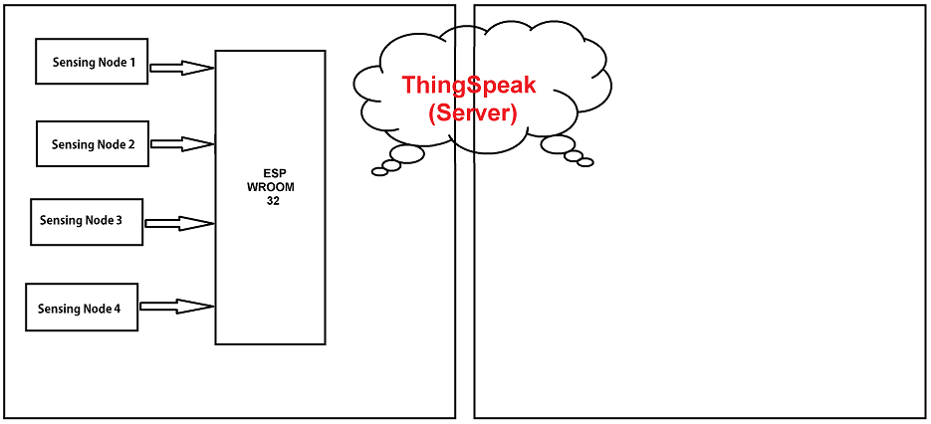

Fig :- Block Diagram of Bridge Safety Monitoring System

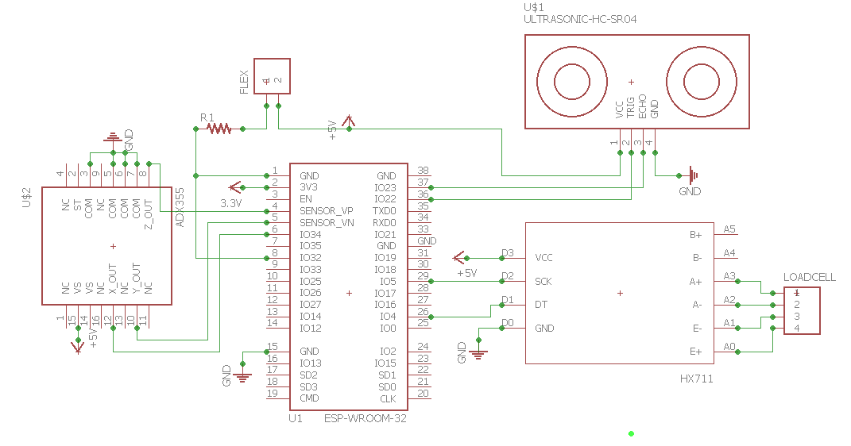Fig :- Circuit Diagram of Bridge Safety Monitoring System

**Working**

**A) Sensing Unit**

Sensing unit is a very important part in the wireless sensor node. There are four sensors used, accelerometer, ultrasonic, load cell and flex sensor. The Accelerometer sensor (ADXL335) is used to detect the tilting angle of the pillar. The features of ADXL335 device are 3-axis sensing (i.e. X, Y, Z), low power, small, thin and BW adjustment with a single capacitor per axis. It can measure the static acceleration of gravity in tilt sensing application. Initially, the situation of bridge pillar is in 90° angle. A bridge under the action of loads and disasters will suffer erosion and damage. At that condition, when bridge pillars are tilted then accelerometer sensor sends the data to the Arduino. Ultrasonic sensor is used to detect and measure the water level. Ultrasonic sensor emits short, high frequency sound pulses at regular intervals. Ultrasonic sensor provides 2cm-400cm non-contact measurement functions. Load cell is used the strain on the bridge during busy hours. Vibration sensor measures the vibration caused on the bridges.

**B) Processing Unit**

Signal processing module consists of two parts which is signal conditioning and high resolution A/D. Signal conditioning is called as manipulating on analog signal conditioning for further processing. Most common use is in analog to digital converters mostly; in signal conditioning stage amplification of the signal is complete. Signal conditioning is consist amplification, filtering, range matching, converting etc. sensor conditioning is used to make sensor output suitable for further processing after conditioning. Sensors data is in the form of analog signal. By using the high resolution A/D converter, we have to convert that data into digital form or digital signal. Here Esp32 is used to process all the analog data from the sensors into digital data.

**C) Transmission Unit**

The converted digital data is transmitted wirelessly on the web server. Here ESP8266 is the medium used for wireless transmission of data.

**D) Server**

It is used to collect the information from the sensing unit provided through the WiFi. The Server provides a platform for the data sensed from the sensing unit and as it is an open data platform and API for the Internet of Things that enables you to collect, store, analyze, visualize, and act on data from sensors. It is used to collect day to day data continuously and monitor it. In case if a condition occurs then the server is been received with the following information and the alert is been given to the person in charge.

